Sprint 0 Product Brief

What’s New User Interface

[Epic #4313](https://app.zenhub.com/workspaces/va-mobile-epics-636d76f8c818bf0010e50a41/issues/department-of-veterans-affairs/va-mobile-app/4313)

### Problem Statement

The mobile application does not have the ability to showcase new or improved content in the application after an update, and new features may be hidden or unknown to a Veteran. We would like to make sure that Veterans can leverage the app to the maximum as soon as new features launch.

### Assumptions and Level of Confidence

1. A What’s New interface would allow Veterans to see new features immediately. It would drive adoption of features and introduce Veterans to a richer feature set within their own experience.

### Risks

1. Not all Veterans have access to every new feature
2. Potentially duplicate content: With the new nav model that Holly is working on, Misty has suggested “what’s new here” copy at the top of each category landing screen that alerts the user to tools/things we've moved and to eventually introduce new features/tools as we add them.
   1. Questions from this risk: Have we already solved this problem with the “What’s new” section on the category landing screens? If we move forward with this feature, should we remove the “What’s new” section from category landing screens?

### Business Goals

* Provide a way to share new features with Veterans in a way that is least intrusive, while still being informative.

### Roadmap

* Content strategy
* User research
  + What would be most helpful?
  + AB testing
  + Investigate future states in discovery
* Use a phased approach
  + Determining the logic and UI for when and how it’s shown, what it looks like
  + Tell “what’s new” via text (see above - content strategy needs to come earlier in the process)
  + Display formatted swipe-able images, short video to demo how to use it / what it does
* It would be stored somewhere in the app so it’s still accessible to users

**V1**

* What’s New UI for releases.

**V2 and beyond**

* Suggested feature logic based on user utilization data and authorized services flags?

### Technical Approach

I see multiple ways to approach this:   
1. Simple, fast version is to save the app version as whatsNewVersion of the app and then check the current version of the app against that. Have a What’s New component with the correct content for that version. If there isn’t content for the build, have a null indicator to skip it.

2. Use a more complicated version that leverages Remote Config to send down what’s new content to the app.

This could also be v1 and then v2.

### Measuring success

### Stakeholders

* Product Manager:
* Architecture:
* Design:

### 

### Important Links

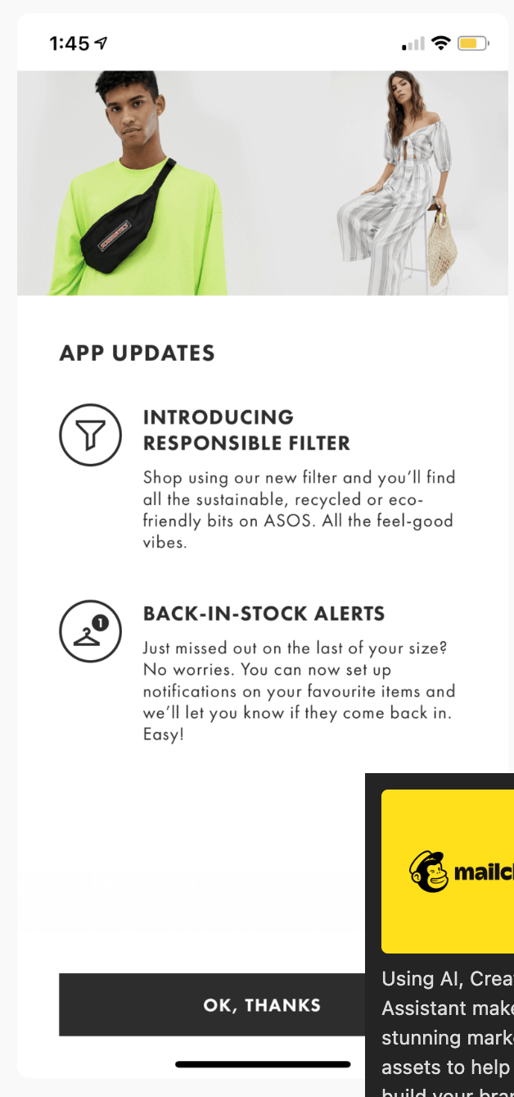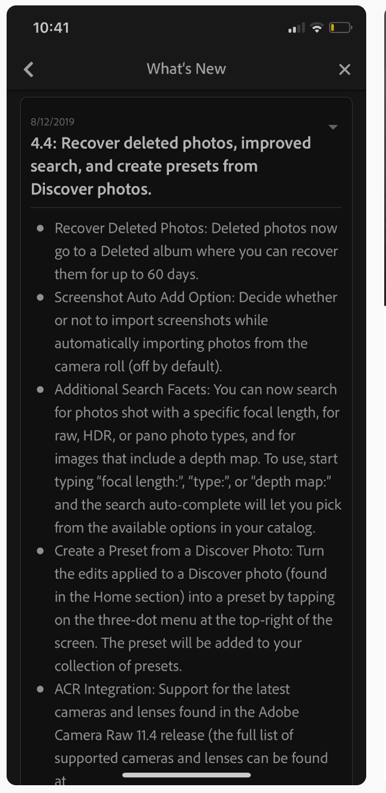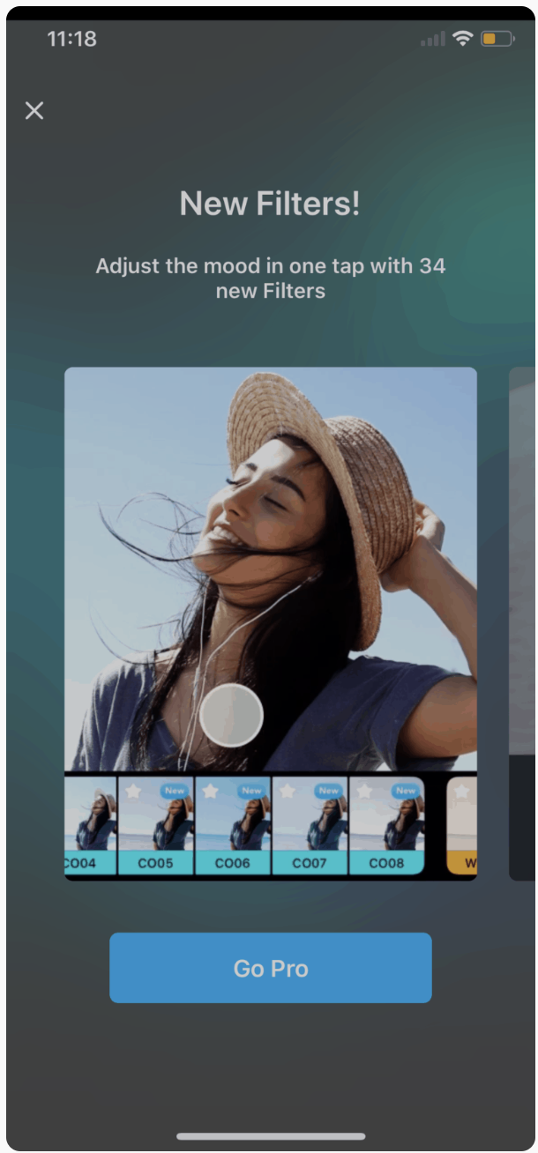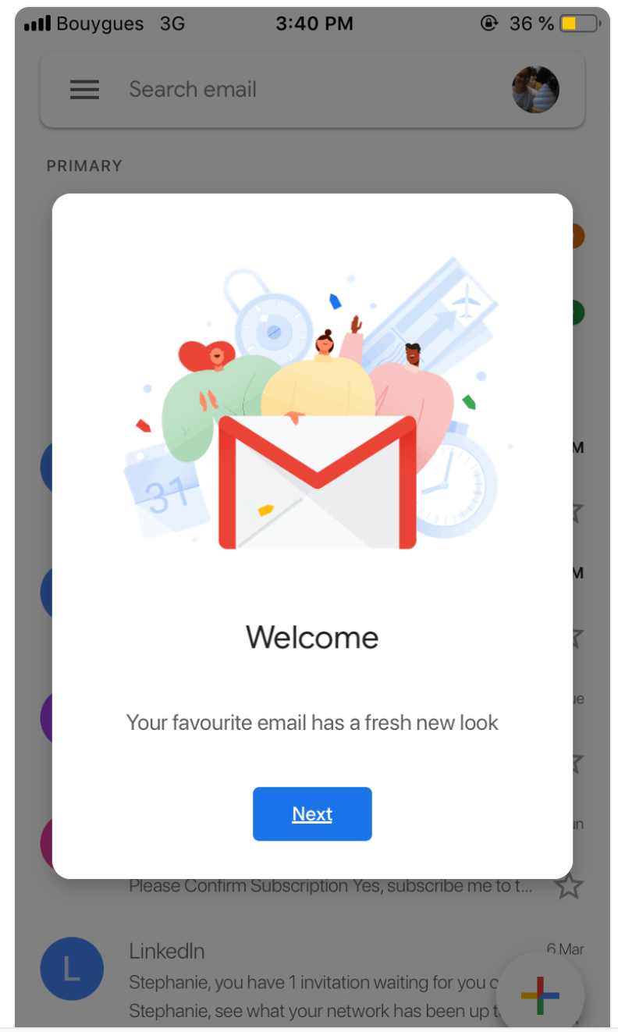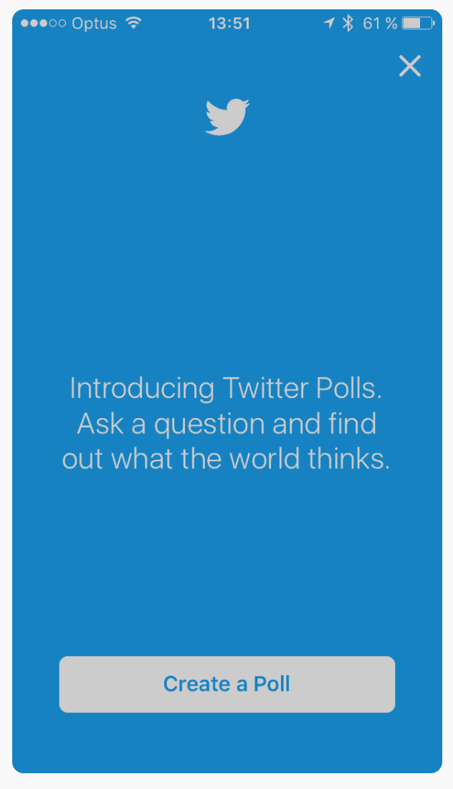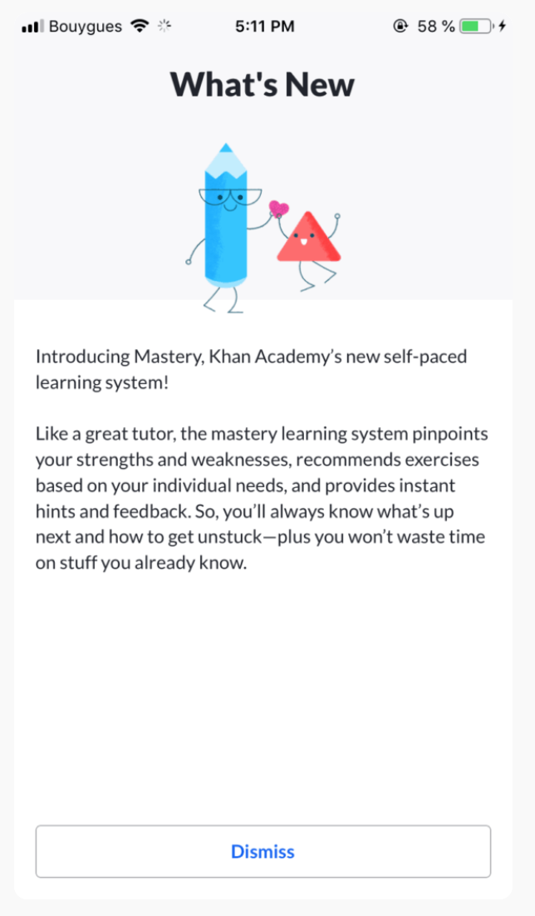

Slack message on OCTO/Sidewide Content considering a “latest updates” component on VA.gov side: <https://dsva.slack.com/archives/C018V2JCWRJ/p1663083311784519>